**Experiment No : 2**

Title : - Creating and Managing Vector Data: a) Adding vector layer b) Setting properties c) Vector Layer Formatting.

Procedure:

1. Adding vector layers (Polygon, Line, Points)
2. Setting properties (Labeling, Symbolism)
3. Creating Polygon vector layer

➢ Select Project→New

1. ➢ Select Layer→Create Layer→New Shapefile Layer

dialog box will appear on the screen. Select Polygon option from Geometry type.

Save the file name to the destination folder .

Add the Attribute you want to show. (Column Name for Table)

b. Specify Data Type of Attribute .

c. Specify the Length of the Attribute. Specify Precision (If Data Type is Decimal)

Click on Add to Field List Button. You can add as many fields (Column Name) as you want for the layer.

The CRS dialog box will appear on screen. Click on the WGS84 option and it will be selected as follows. click on OK

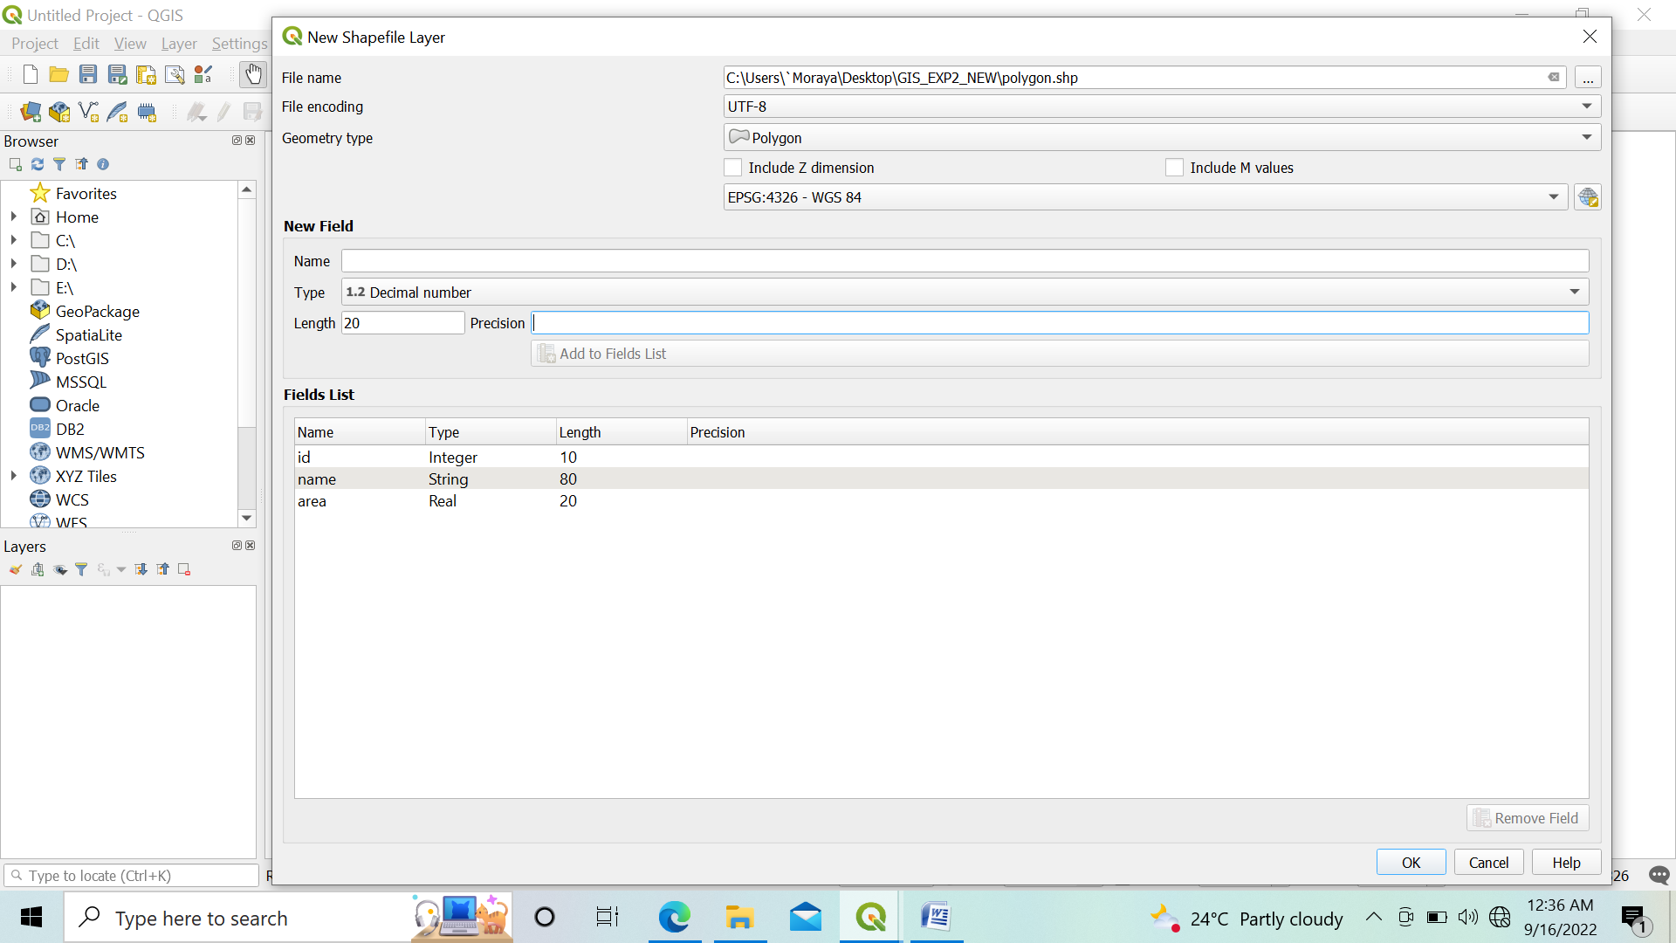

**Steps to plot polygon :**

Select the Polygon Feature from layer panel.

Click Toggle Editing Button → Click on Add Polygon →Now place the cursor at the location where you want to place the polygon. for polygon layer minimum 3 points should be selected.

Save the newly added polygon.

Set style for polygon by using property window. Select pattern as you want and click on OK.

Same way we can add one more polygon layer for Gardens.

Polygon will look like this

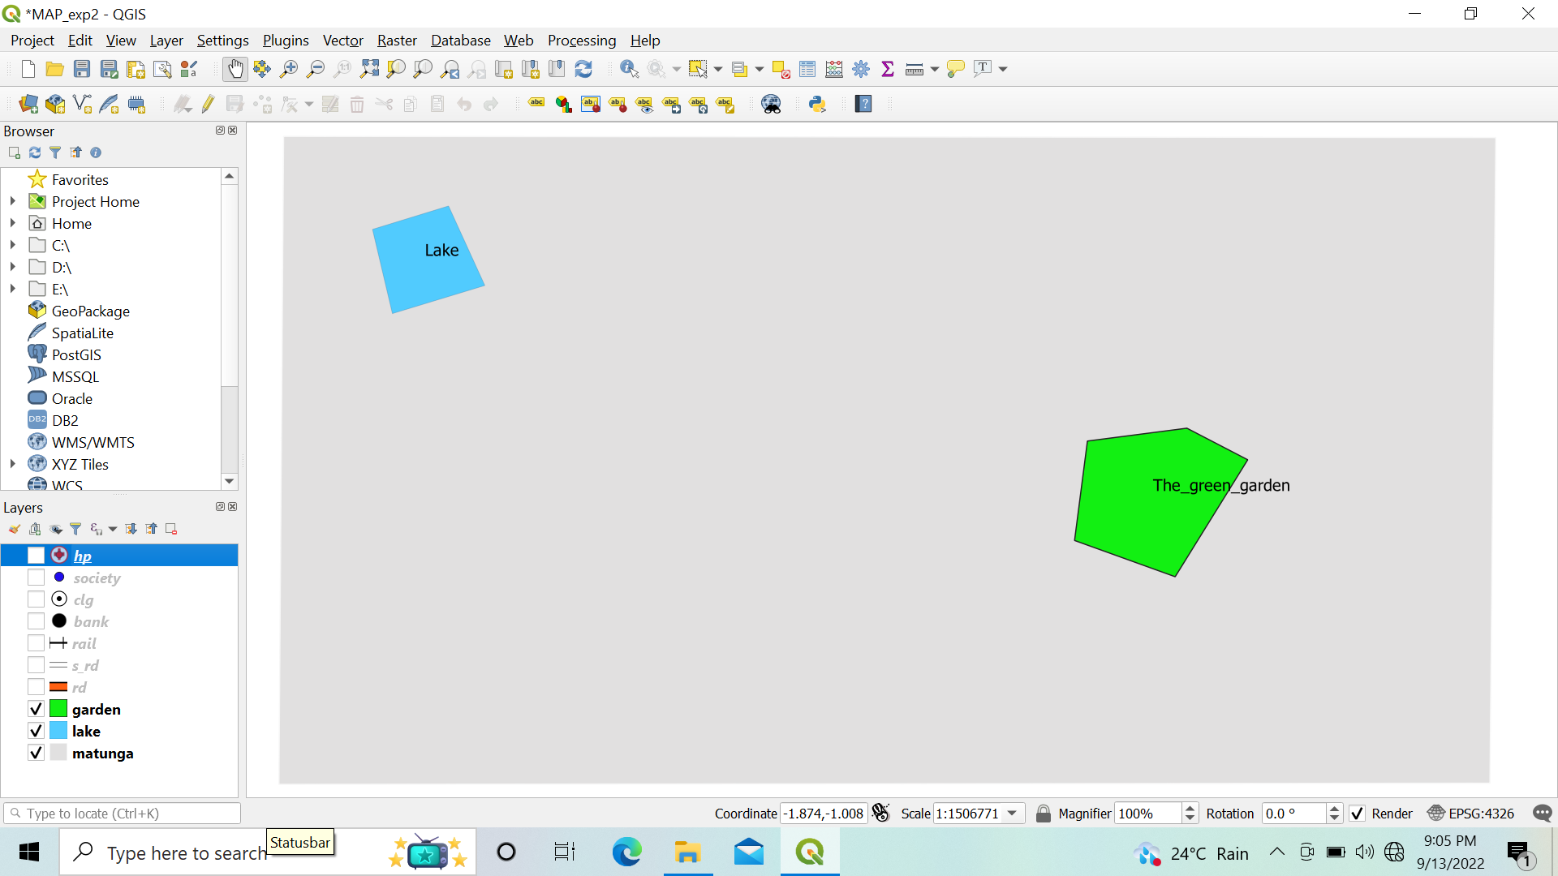

1. Creating Line vector layer

➢ Repeat the same steps as we have done for polygon layer.

➢ Select geometry type Line.

Road layer : To plot road click on Add Line Feature set style for Roads in the same way as we have done for polygon.

**Label :**

click on properties → select label and set single label property.

To merge roads , Go to properties of road then → select symbology → Click on Advanced button select Symbol levels →Check Enable symbol levels option →Click OK.

Roads will look like this :

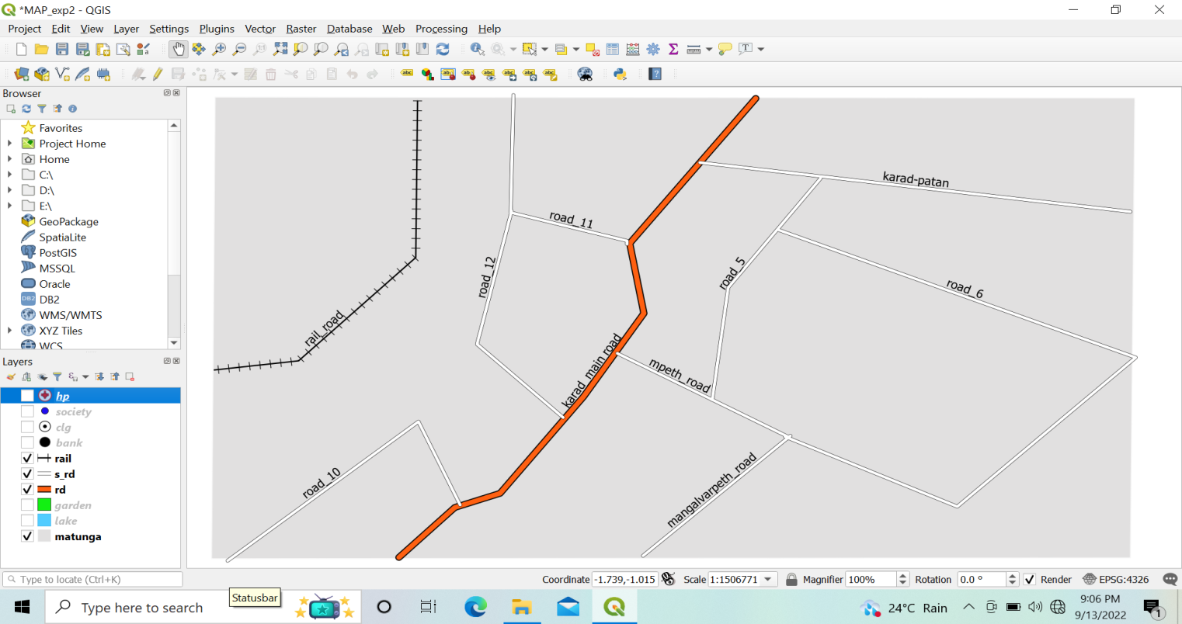

C. Create Point vector layer

➢ Repeat same steps to add point layers as we have done in previous layers.

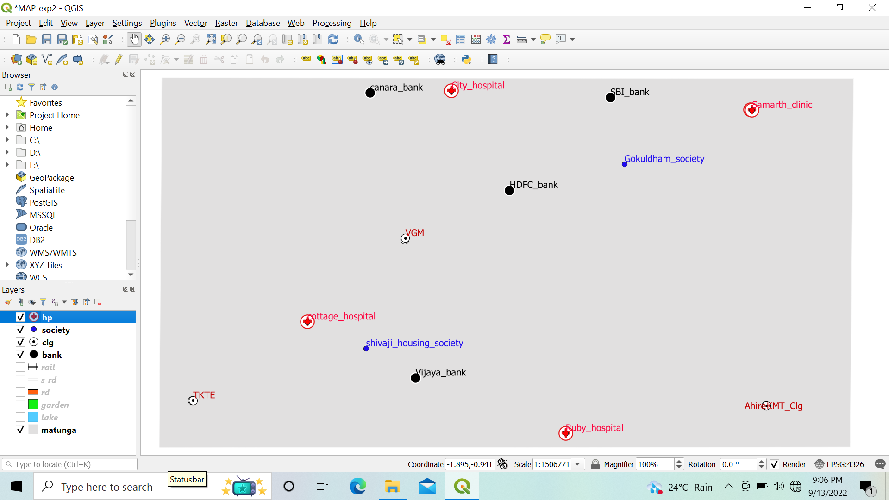

The Final Map will be as follows :

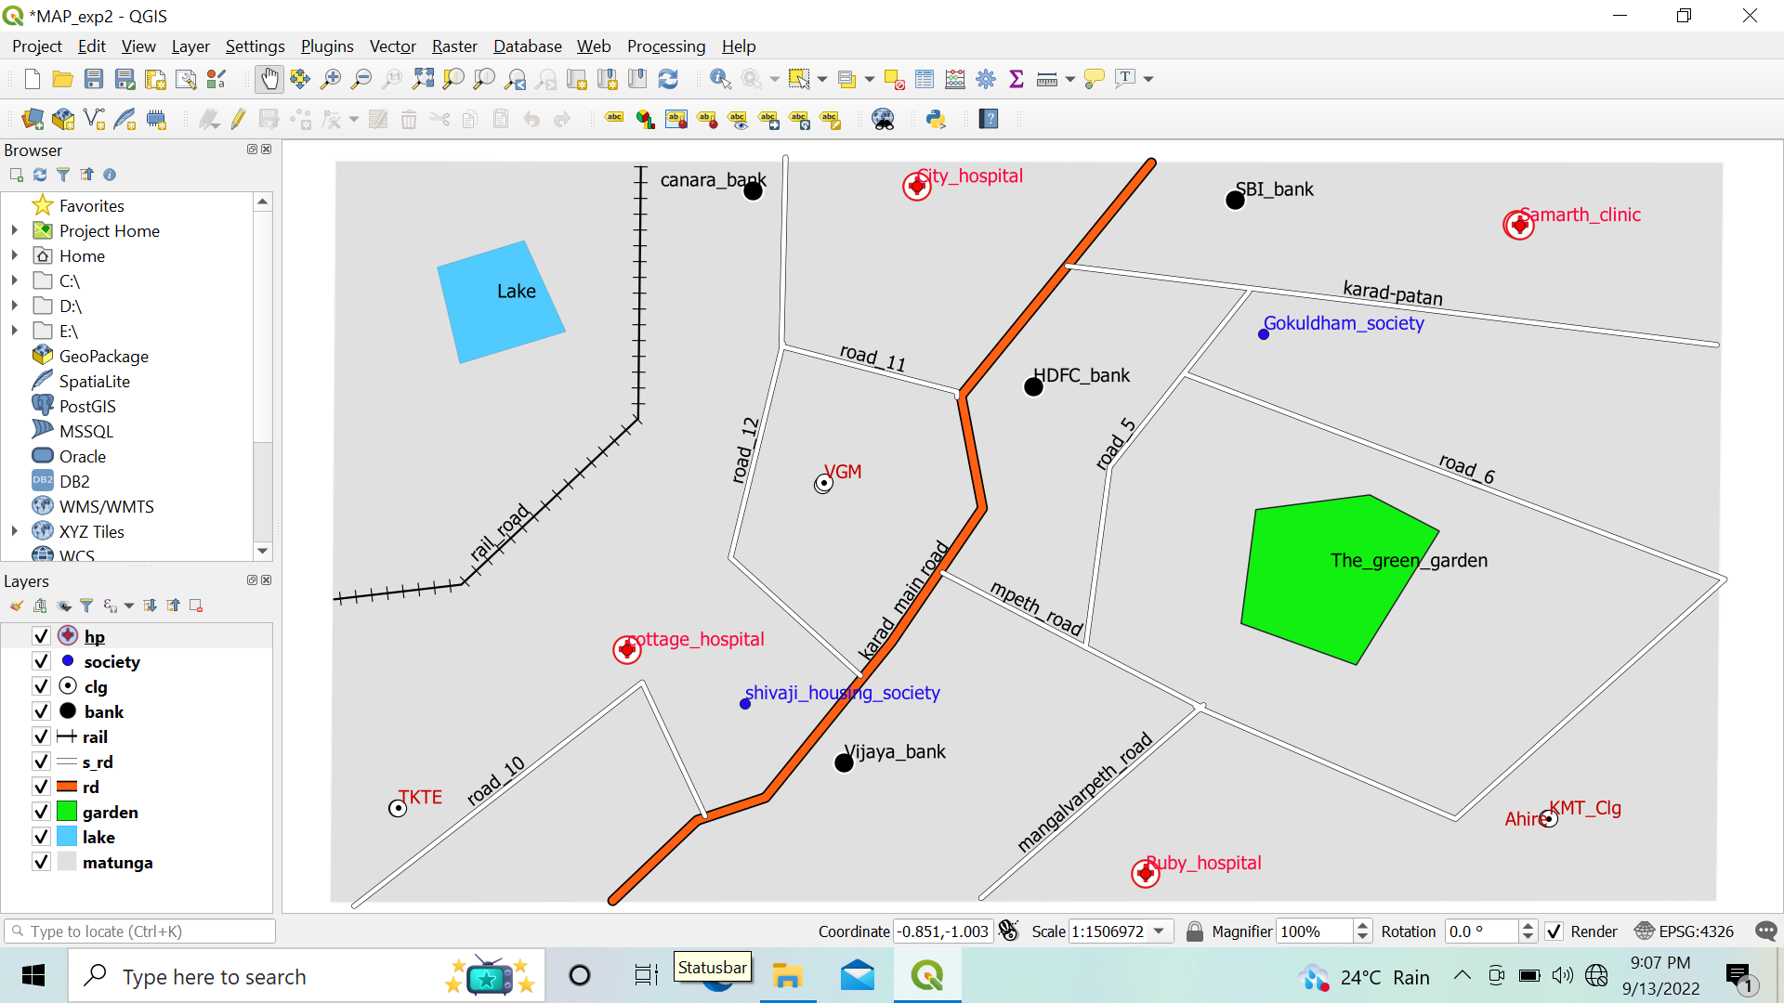

**Calculating line lengths and statistics**

**Step 1:**

Go to Layer → Add Layer → Add Vector Layer

Add the following file to project IND_rails.shp and India Administrative Map(IND_adm0 ).

Double Click on IND_adm0 .

Select →symbology → Select any outline style from below given options.

Press OK .

The display window will appear like as follows :

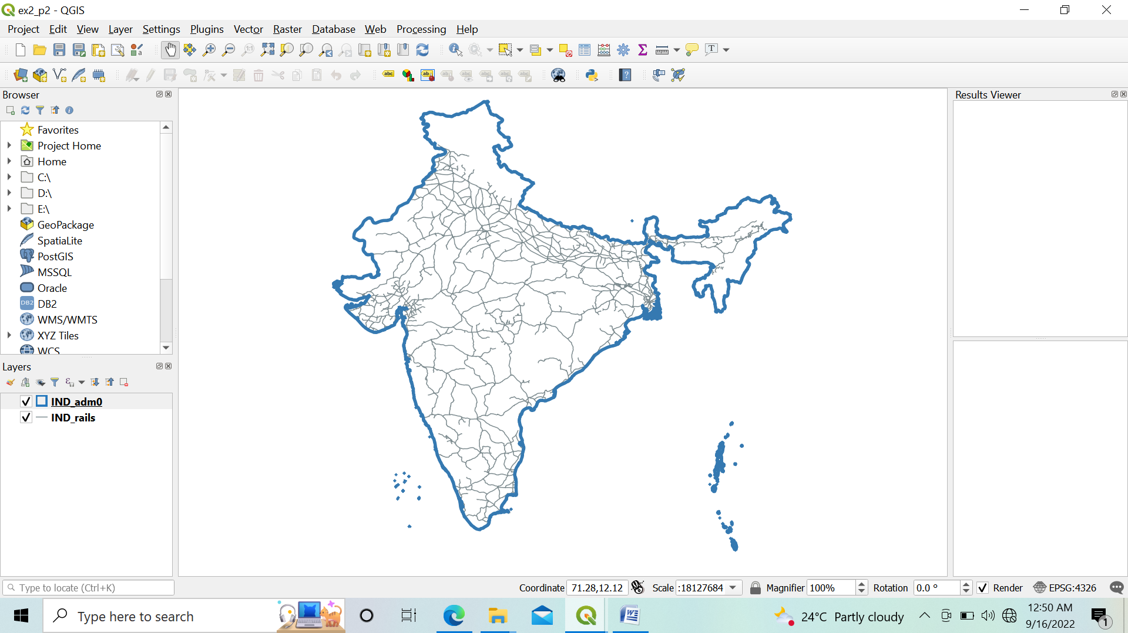

**Step 2:**

In Layer Pane, Right click on IND_rails → Open Attribute Table

Press Open Field Calculator using button.

Set the output field as “Track_Len”, field type to “Decimal Number”

From Function List search $length or go to Geometry → Select $length

Set expression as $length /1000

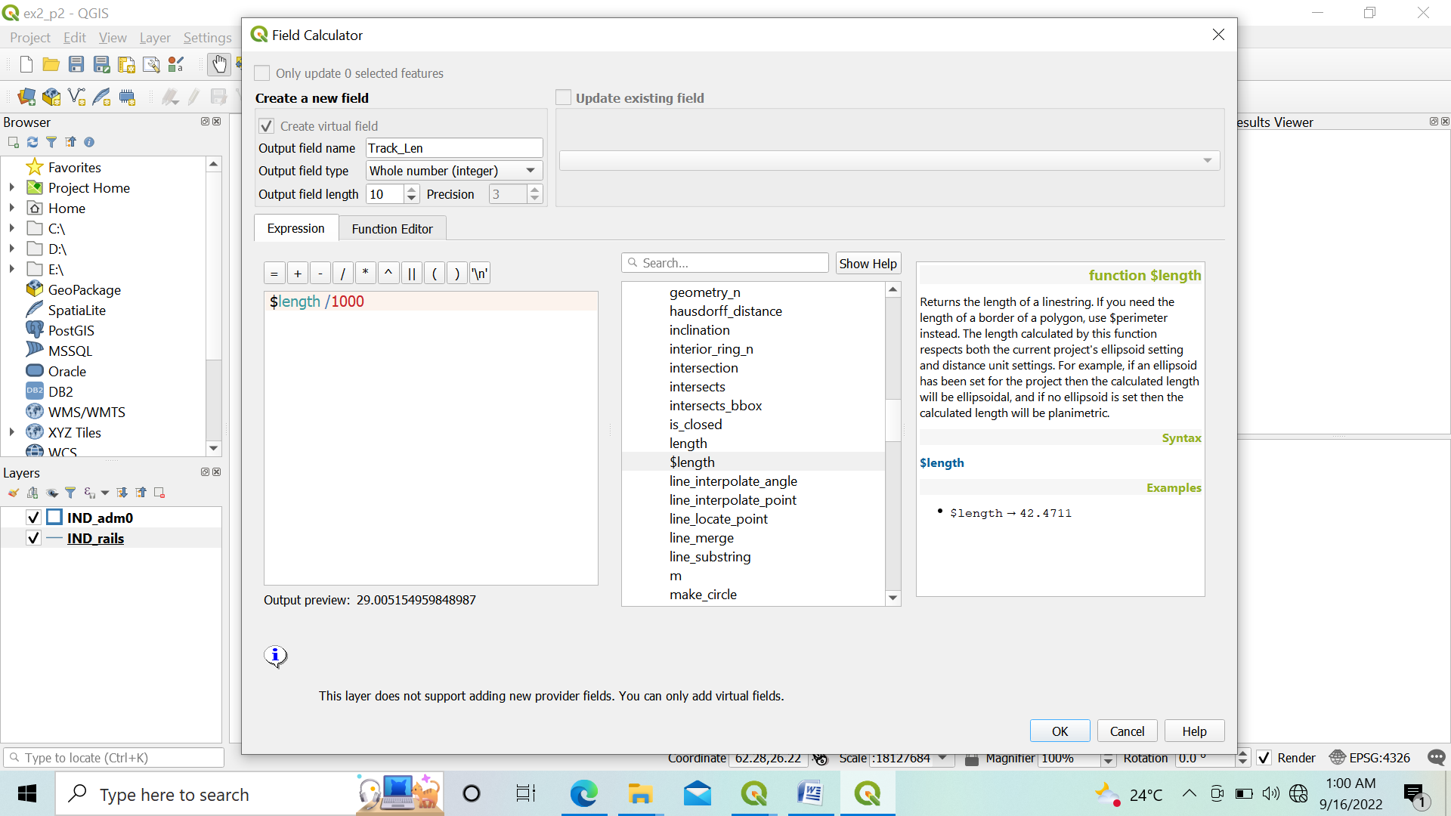

Press OK. A new column the length of track in KM is added to the attribute table .

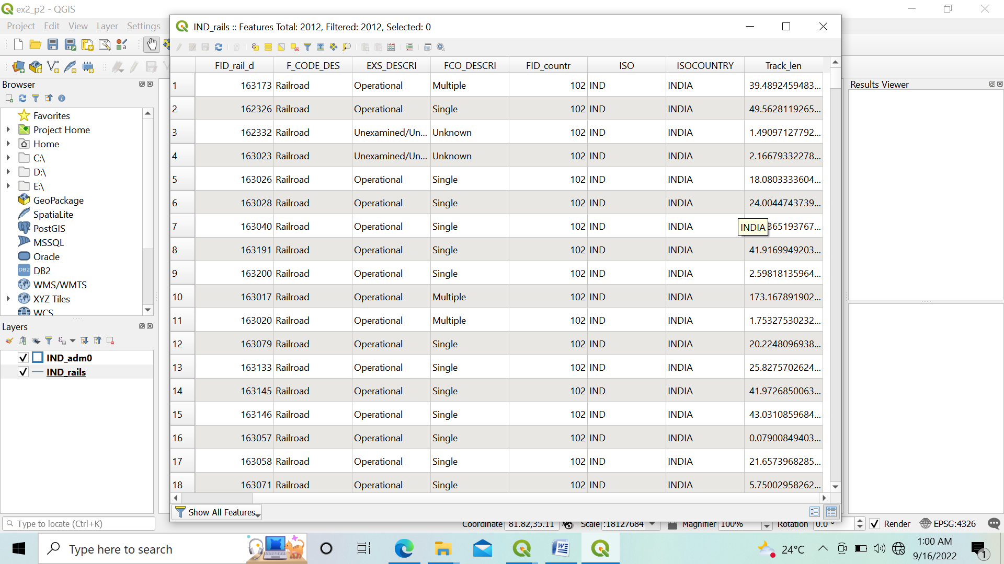

**Step 3:**

Press CTRL+S or click. Close the attribute table window.

For calculating the total length of Railway tracks in India.

Select Vector→ Analysis Tools→ Basic Statics for Fields

Select IND_rails layer from input layer. And select Track_Len in “Field to Calculate statistics on”

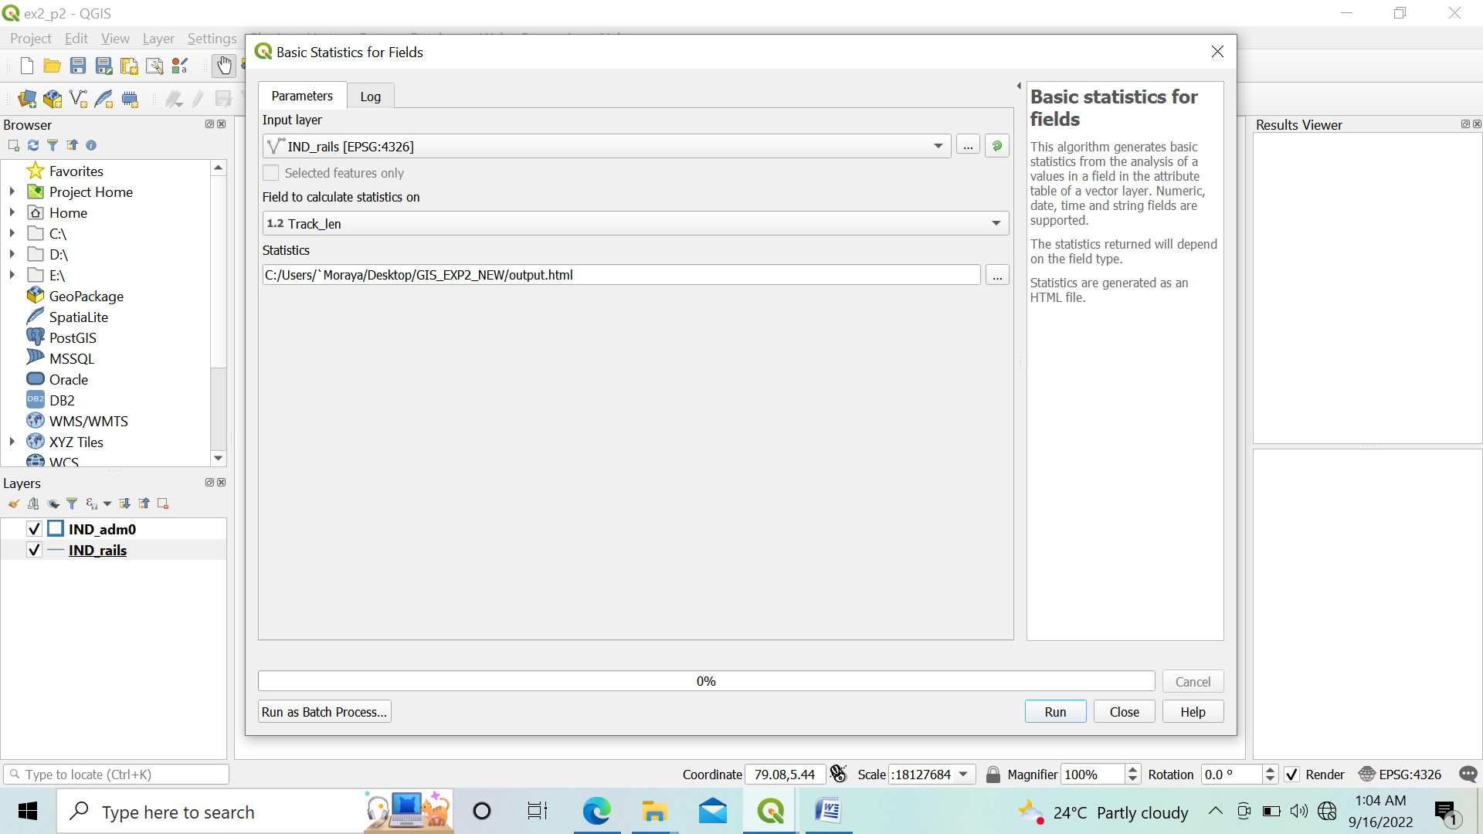

Press RUN. The Result is

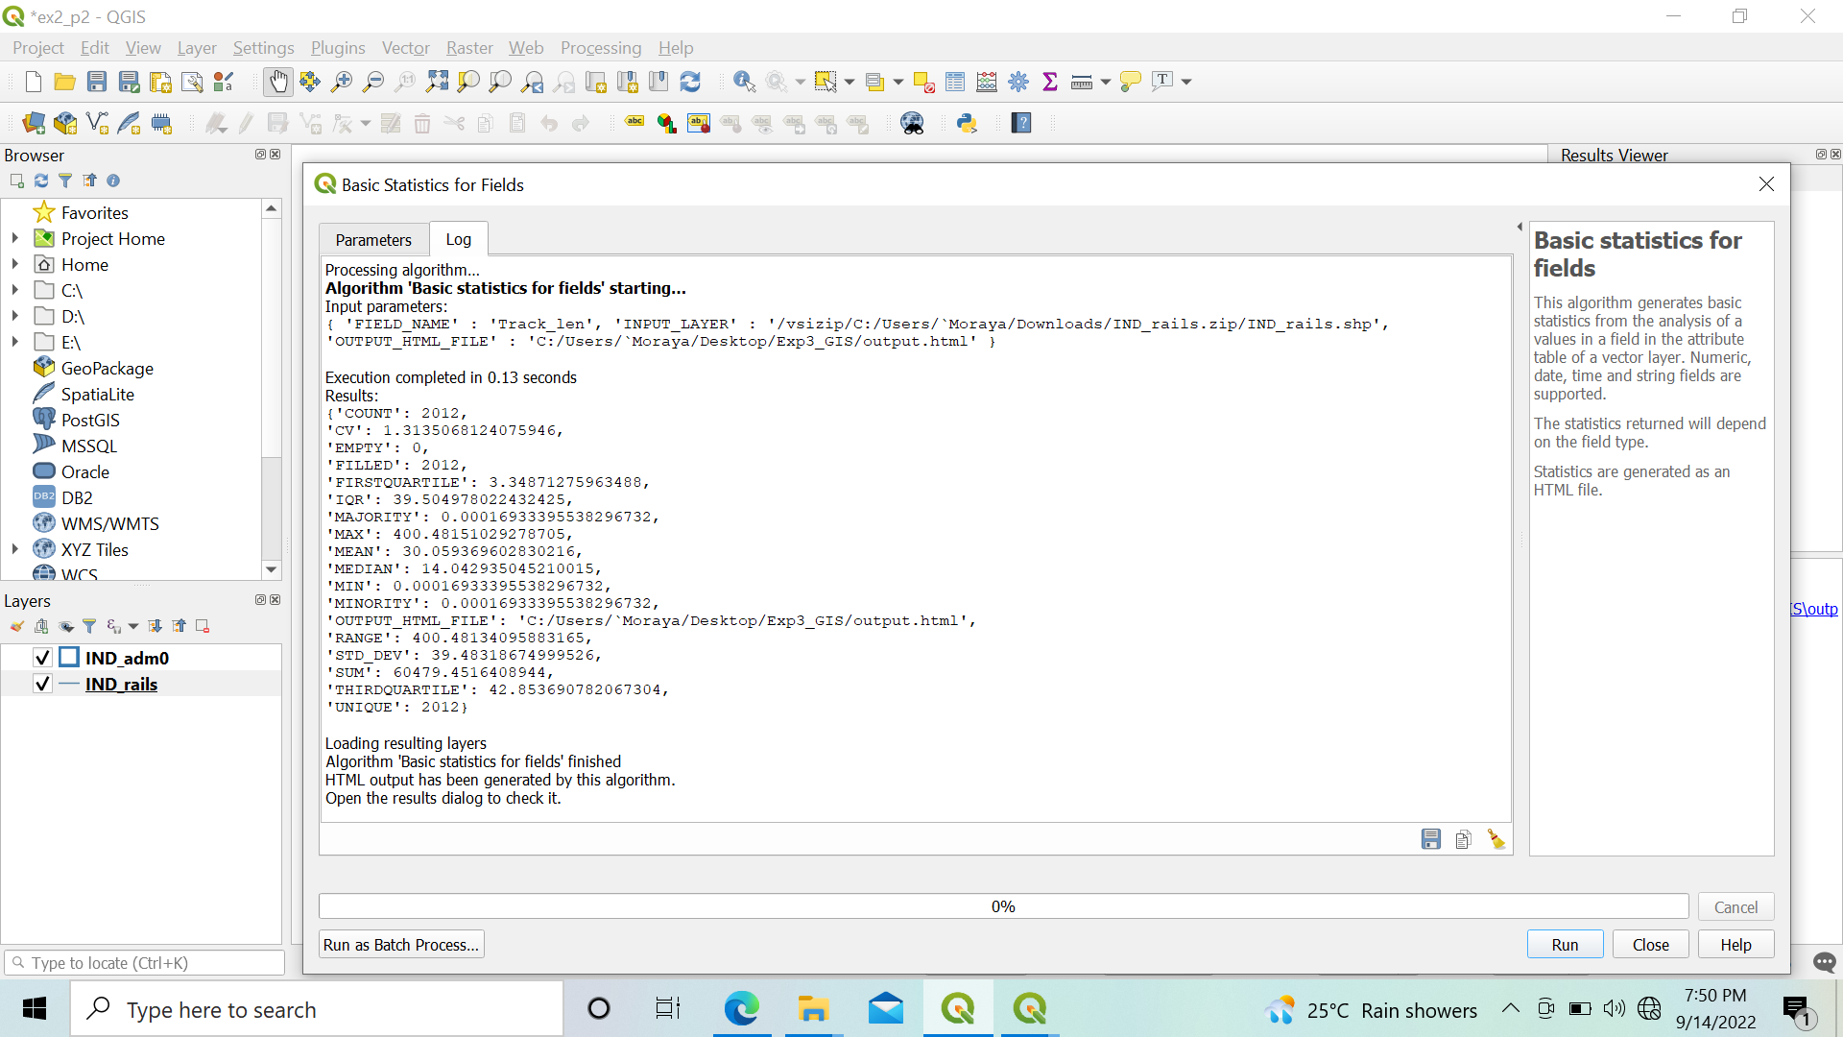

The above statistics show that the total length of Railway track in India is 60,479.45 KM.